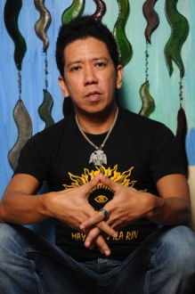
The Director:
Auraeus Solito is an internationally-acclaimed Filipino independent filmmaker chosen recently in Take 100, a survey of the 100 most talented film directors in the world. His first feature film, Ang Pagdadalaga ni Maximo Oliveros, won 15 international awards and was the first Filipino film invited to the Sundance Film Festival and has been the only Filipino film nominated for an Independent Spirit Award (for Best Foreign Film). His award-winning body of work has taken him to the most prestigious film festivals in the world including Cannes, Berlin, Sundance, Toronto, Rotterdam, Pusan, etc. His latest film, Busong Palawan Fate, was an official selection at the Cannes Film Festival Directors’ Fortnight earlier this year and earned many positive reviews there including a very moving ovation from film lovers from all over the world. Busong won awards at the Cinemalaya Film Festival including Best Director, the prestigious FIPRESCI Prize at the Eurasia International Film Festival, and the Tomorrow’s Cinema Award at the Brussels Festival International du Film Independant. Aureaus’ style of filmmaking elaborates the “Manunga Banar” an indigenous concept meaning, the ‘beautiful truths’ that make us human.

The new film: Tungkul (The Shaman King)
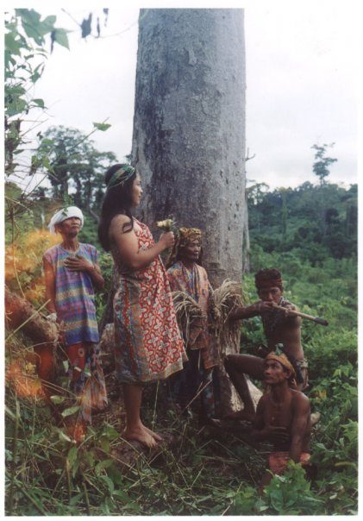
Tungkul is the prequel to Busong. It is the mythological tale of the last Shaman-King of Palawan (an island province of the Philippines). The tungkul dreams of a great flood that destroys his people. To save his children, he passes his great magic to them and retreats to the mountain of forgetting. The great magic of Palawan which previously belonged only to the tungkul is now split into the Dua Culambo the spell that separates the rain, the Dua Bata-bata the spell of eternal youth, the Parimanis the spell of absolute beauty, the Sepuko Banar a powerful blowgun that kills enemies instantly, and the Lihim na Ngaran ng Lupo the secret name of the stonefish that protects against their lethal poison. The children use their magic selfishly bringing themselves closer to the tungkul’s premonition. Tungkul, Busong and a third film currently in development, Sumbang (Origin), form The Palawan Trilogy of films that Auraeus has planned for over a decade. Tungkul will be shot entirely in the native tongue, Palawanon --- thus the film is also a document on the language of the Palawan people.

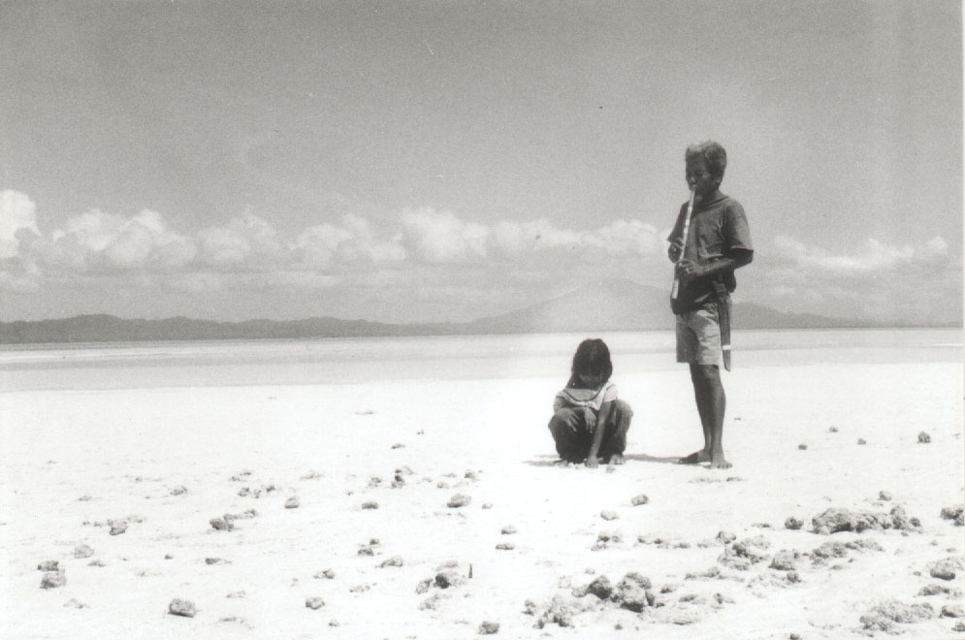
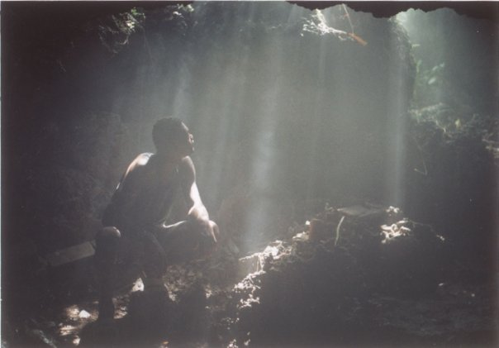

Join us in this new film adventure!
We strive to be always pure and original --- never pandering to particular tastes, western or otherwise. In Warsaw, with Busong Auraeus “provided a new benchmark in cinematic poetry” according to Esensja, the magazine of popular culture. In Almaty (Kazakhstan), “the poetic language separated Busong from the other films” according to FIPRESCI, the Federation of International Film Critics. And in Brussels, Busong represented innovation in film which is why it won the Tomorrow’s Cinema Award. Frederic Boyer, artistic director of the Cannes Directors’ Fortnight said Busong is “unique and wonderful!”

Our motto: Art first.

A simple agreement
Your support earns you a producer, co-producer or sponsor credit on this film which we guarantee will be of the highest quality. As producer or co-producer you may want to attend some of the shoots and Auraeus will be happy to welcome you on the set to observe/learn about his filmmaking process. Additionally, as Auraeus is already being invited to submit his next film to the most prestigious film festivals in the world, we will also invite producers and co-producers as filmmakers to join us in attending the ones that select it --- this can be a fun and wild adventure on its own! Finally, we will share any of the proceeds of the film with you: producers and co-producers get 50% of the net-revenues, divided proportionately according to contribution.
Sponsor level: <$5K
Co-producer level: $5K or >
Producer level: $10K or >

Contact:
Jong de Castro – Executive Producer

Philippines: USA:
Solito Arts Productions EXIT STRATS, LLC
329A Sta Teresita St. 4011 Gamma Street
Sampaloc, Manila San Diego, CA 92113

Email: jong@exitstrats.com
Mobile: +1-619-450-3058 (U.S.)

