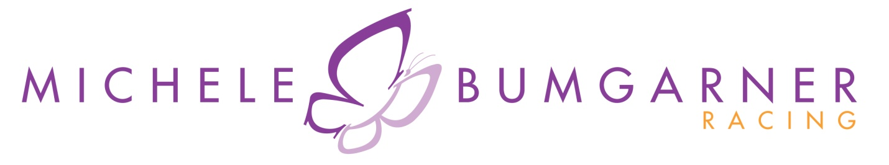
Bumgarner Mixes It Up at Barber Motorsports Park

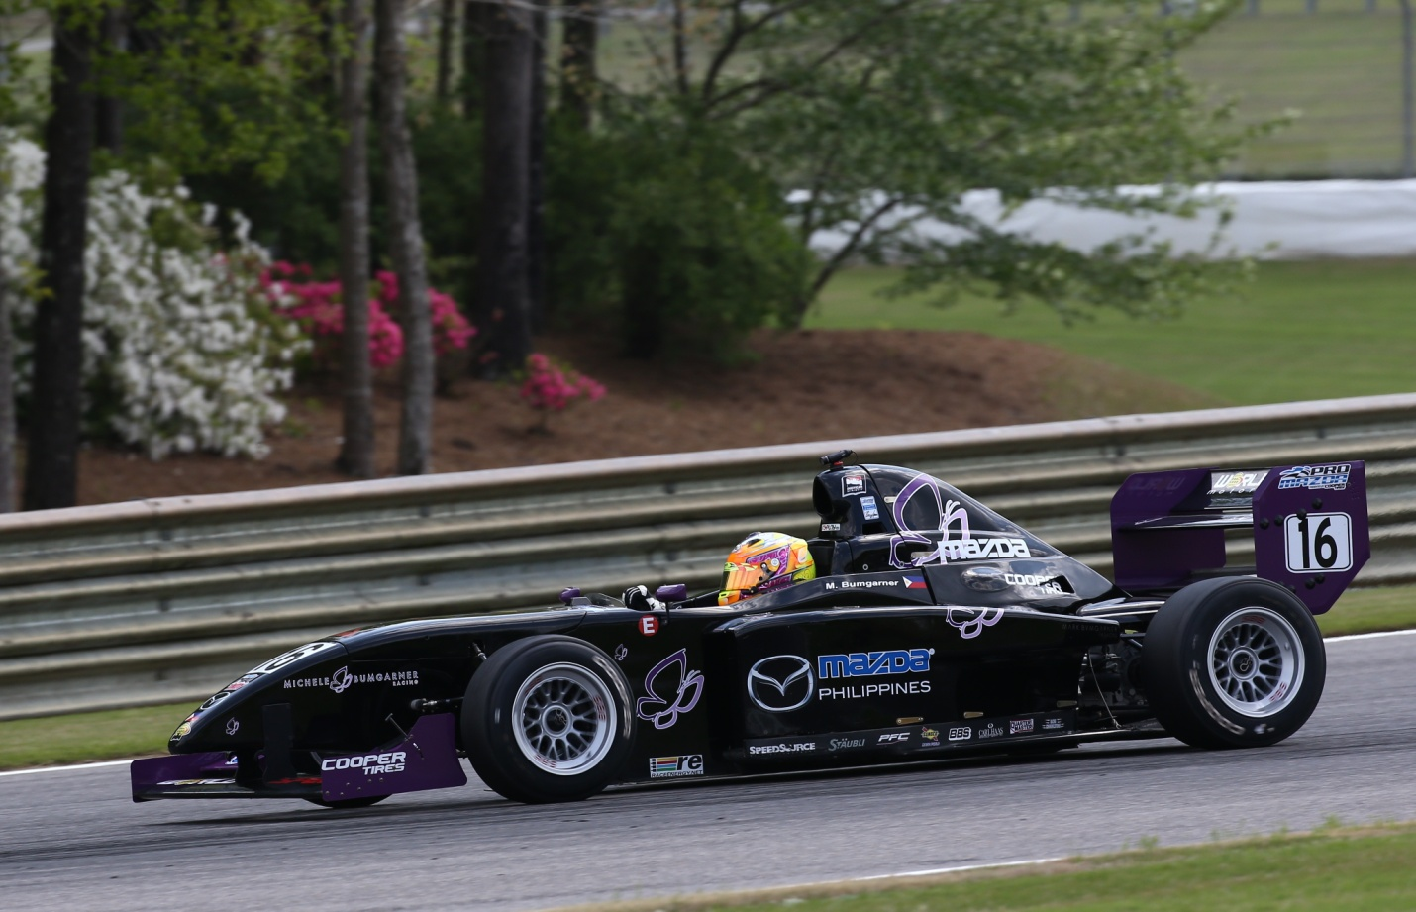
Photos @ Indianapolis Motor Speedway Photography, LLC
Birmingham, AL - In Rounds 3 and 4 of the Pro Mazda Championships Presented by Cooper Tire, Michele showed that the off track work has been paying off as she continues to elevate her game on track. If you have been following Michele on Twitter, you know that she and Flat Johnny Unser have been a lot of places, working hard to keep her ready and focused for the race weekend, including daily workouts at PitFit, afternoon hot yoga sessions, and time on the highly sophisticated race simulator at Racecraft1.
At the beautiful Barber Motorsports Park, truly one of the more elite race facilities in the country, the weather was near perfection. As spectators found their favorite viewing spots, Michele went to work with an early morning qualification session. She would post a time quick enough for the 16th spot on the grid. Note: all of the cars on track are within a span of two seconds. The competition is just flat tough. With cooler temperatures in the morning, the crew knew that the track would be warmer and bit slicker for the race in the afternoon. They made a few changes to accommodate the difference in grip that Michele would need. The result was a flawless performance. Michele made several gains and would finish Race 1 in 14th.
After each race, Michele spends time debriefing with her engineer and driver coach. This consists of her conveying how the car was handling at different turns and places on the race track. It also includes reviewing the in-car camera footage captured during the session along with the data that is recorded. The data or telemetry will show Michele and the team key information - like throttle input (when she is on the gas coming out of corner and how much gas she’s giving it) and brake input (when she gets on the brakes entering a corner and how hard she is pushing on those brakes.) All of this information then helps the team make adjustments to the car and Michele make adjustments to how she is driving the car on this particular track.

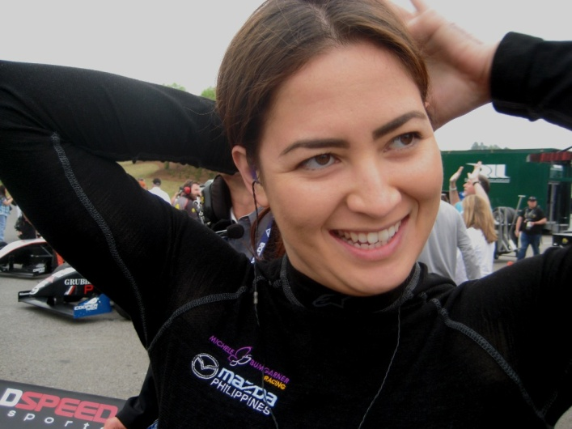
Race 2, was the first of the day on Sunday. The weather was overcast and a bit damp. So again, different track conditions to contend with, but Michele was excited to get going. She would start Race 2 in the 17th position. The start was clean and Michele was gaining on the car in front of her. Heading in to Turn 5, the #6 of Ballario came in hot behind Michele in attempt to overtake her. As Ballario closed the space available on track, Michele kept her foot in the gas, let the gravel fly from the track edge and then made it a drag race to the next corner. The battled continued, but Michele managed to capitalize on the inside line advantage, leaving the #6 in her dust. Several laps later, Michele spun but keeping her cool, kept the car running and got back on the throttle. With only 5 laps remaining, she managed to make up the lost time and pass her way back to a 15th place finish. Her average lap speed of the race was 94.5 mph.
Michele stated, “Well, I didn’t like the spin! But overall it was a successful weekend, for sure! I know that I continue to improve my lap times, but more importantly I’m really learning things about this Pro Mazda car. So many of the other drivers have several seasons in these cars and have been in the seat consistently, so I have to be patient with myself – and fortunately I have a team around me that will allow me to get there on my own terms. I’m really enjoying the whole Mazda Road to Indy, meeting all the fans that come out to the track is great. I’ve even got several of the guys wearing my MB Butterfly stickers! So it’s all good and it felt great to get that last pass for position on the last lap of the last race.”
Racing is simply not possible without supporters and Michele expressed her appreciation for Mazda Philippines, Oakley and the City of Olongapo for their support. Your support of these companies and the town is appreciated.

Next Appearance: Friday, May 2: Inspiring Women Singles Conference. http://inspirewomen.org/

Next Race: May 8-10, 2014: The Inaugural Grand Prix of Indianapolis at the most famous race track in the world – the Indianapolis Motor Speedway. Home to the Indy 500 – the Inaugural Grand Prix race weekend will utilize the road course at “the Speedway” and will kick off events for the month of May that will culminate in the 98th Running of the Indianapolis 500 Mile Race.

Gawad Kalinga USA: www.GK-USA.org
Support the Gawad Kalinga movement through the Bayani Challenge USA. We are calling out to all bayanis (heroes) to support the activities of Gawad Kalinga in the US and the Philippines by raising $100 each for ten (10) months into the Bayani Fund. For more information, see Bayani Challenge USA. For check payments, please send your checks to: GK USA 13860 Stowe Dr Poway, CA 92064. Online Donations are also possible.

Facebook: Michele Bumgarner Racing Twitter & Instagrams @MicheleBum
Results and Series Coverage: www.StarMazda.com and http://roadtoindy.tv/
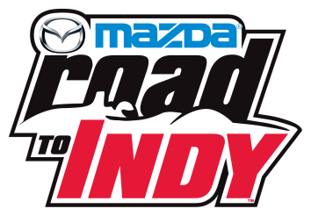
Media Contact: LeeAnne Nash, 765-336-9680 / Nash@NashPerformance.com

