THE BALANCE CONCEPT IN HEALTH AND NURSING
A Universal Approach to Care and Survival
By Daisy Magalit Rodriguez, MN, MPA, RN
Book Description:
The central idea in this book is the concept of balance composed of five universal elements that support survival of all human beings - adaptation, equilibrium, homeostasis, needs, and health – and how it applies to health and nursing. Behavior is the key that unlocks these elements through interaction with the internal and external environments. The concepts of imbalance, personality, open systems, behavior pyramid, culture, technology, and physical forces are viewed as influences that affect behavior. Using existing related concepts and theories derived from the social, nursing, and physical sciences, a novel view of the health-illness continuum was conceptualized. From this theoretical background, a new nursing model was developed – the Balance-Health Nursing Model (BHNM) using balance as a framework in the nursing process. A Balance Health Assessment Tool was developed with a sample case study to demonstrate its use. This view of balance offers an alternative approach to health and illness and the role of nursing and other health care professionals in their practice settings.
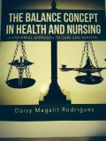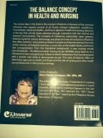
FRONT COVER BACK COVER

